NETT Road Crossings
Full descriptions are available in “Parking on the NETT” Document

Views of Road Crossing on the Chaparral Trail portion of the North East Texas Trail
This document is intended to assist Trail users in identifying potential parking and access/egress points. Do not block trail, roads, gates, or drives.
Approximate Mileages are from Audie Murphy Trail Head in Farmersville, Tx

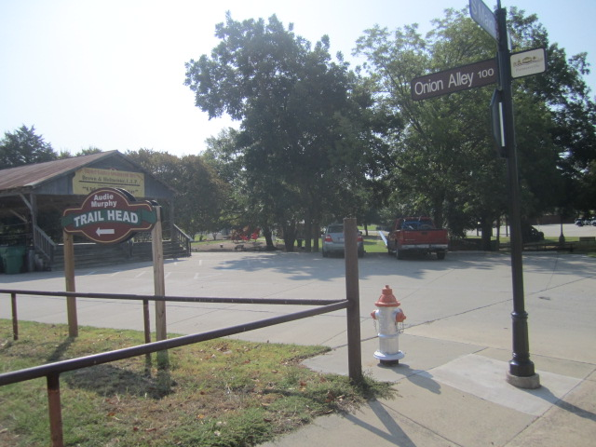 | 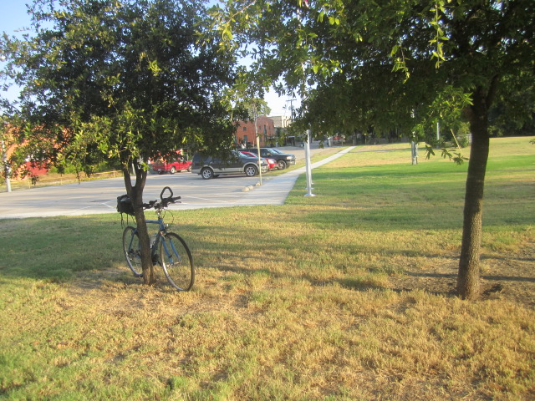
(1) Audie Murphy Trailhead Onion Shed Parking  Shared With Other Events | (1) Audie Murphy Trailhead Parking  Shared With Other Events
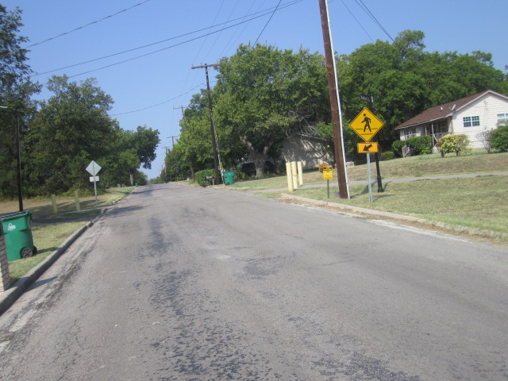 | 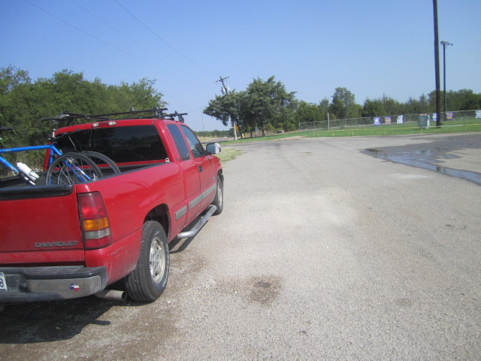
Typical of Farmersville Street Crossings  Hill, College, Houston, and Murchison Streets  No Available Trail Parking | ( 2) J. W. Spain Atheletic Sports Complex Parking  Trailer and Vehicular Shared Parking, Merit St.
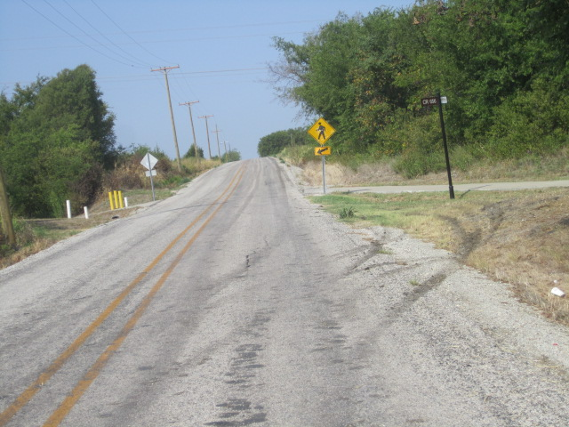 | 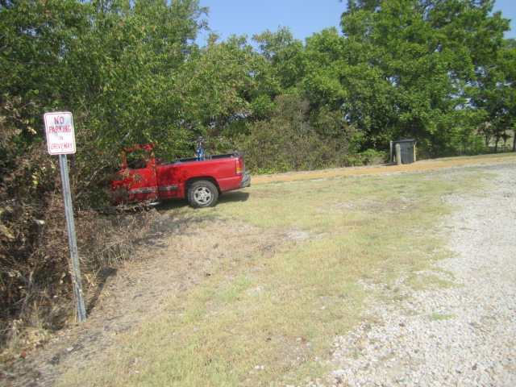
(3) Collin County Road 656 Trail Crossing  No Available Trail Parking | (4) Collin County Road 658 Private Drive Access  Limited Parking, Obey Sign
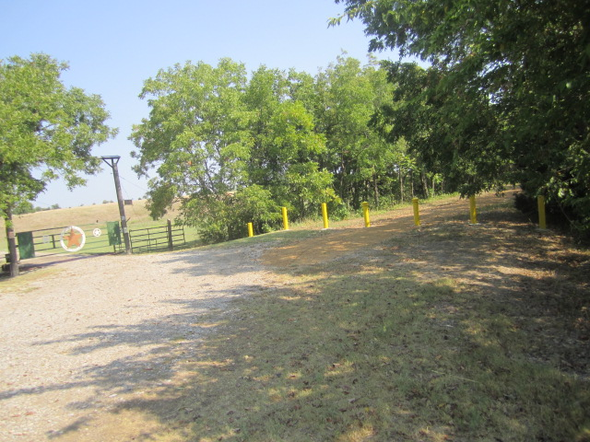 | 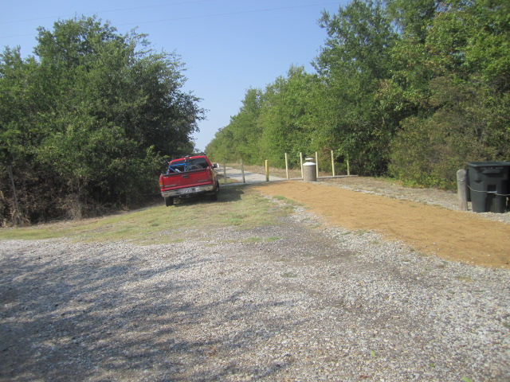
(5) Collin County Road 658 Private Drive Access  Limited Parking,, Do not block gate or trail. | (5) Collin County Road 658 Private Drive Access  Limited Parking, Do not block gate or trail.
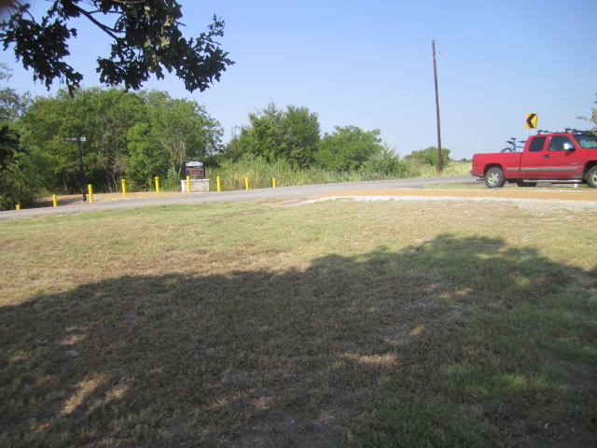 | 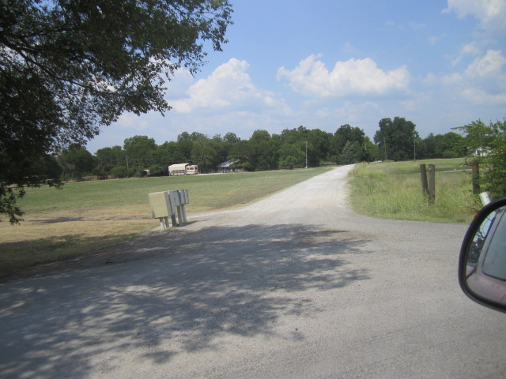
(6) Collin County Road 658 Trail Crossing Limited Parking, Stay in ROW, Do not block Trail or Road | (7) Private Road 5101 from Collin CR 700, Advise Emergency Trail Access Only from Private Roads
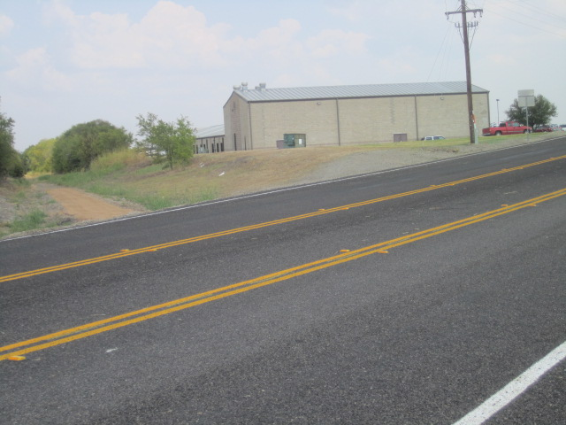 | 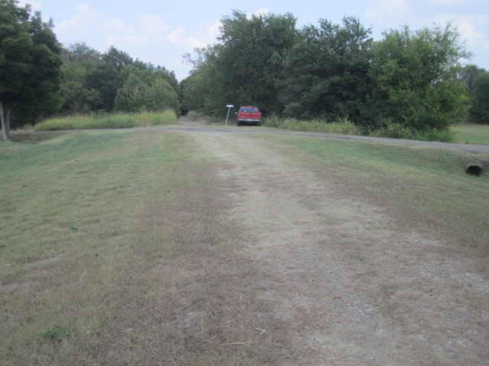
(8) FM 2194 Trail Crossing at Bland HS in Merit  Small Parking Lot by HS Maintenance Building | (9) Lake Road Trail Crossing in Merit  Lots of Mowed Parking beside Trail, Both Sides
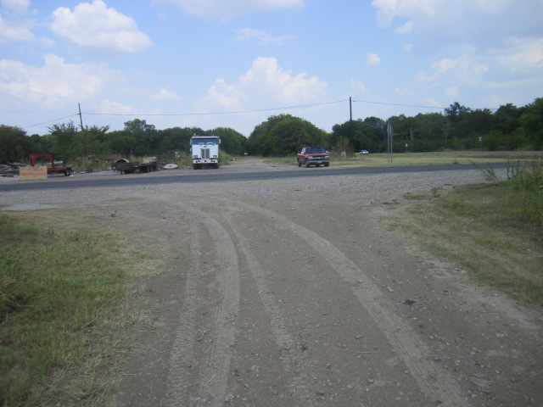 | 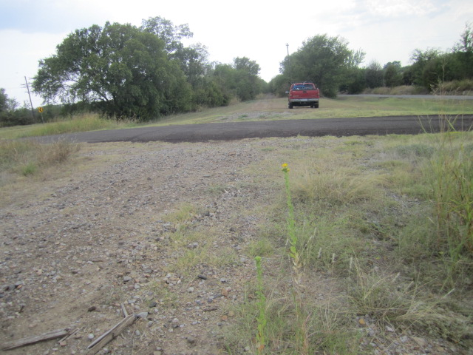
(10) FM 36 Trail Crossing in Downtown Merit  Caution, ATV and Pickup Traffic West to Lake Rd | (11) Hunt CR 1108 Trail Crossing Close to Merit Cemetery. Trailer and Vehicle Parking Available
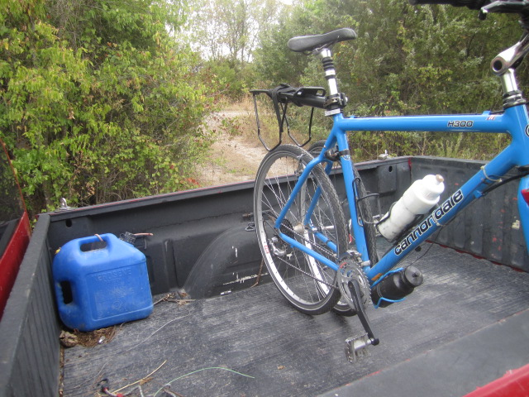 | 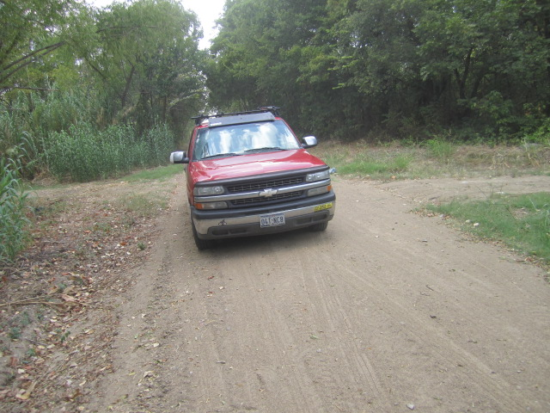
(12) Trail Access off of Hunt CR 1108  Roadside Standing Only | (13) Hunt CR 1101 (South) Trail Crossing  No Adequate Parking, Dirt (Mud) Road
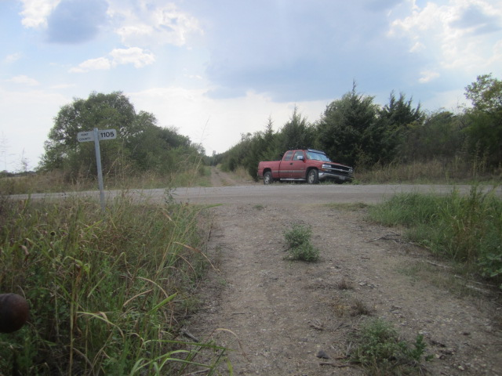 | 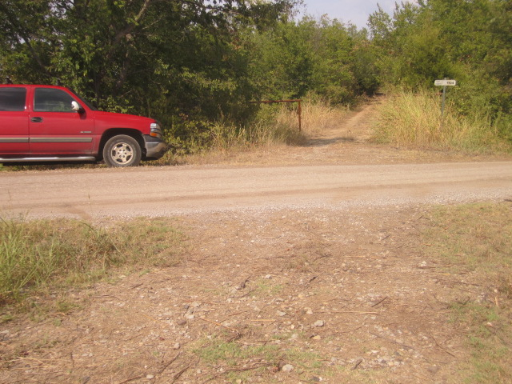
(14) Hunt CR 1105 Trail Crossing  Marginal Parking, House East of Intersection | (15) Hunt CR 1104 Trail Crossing  Very Little Parking, Gravel Road
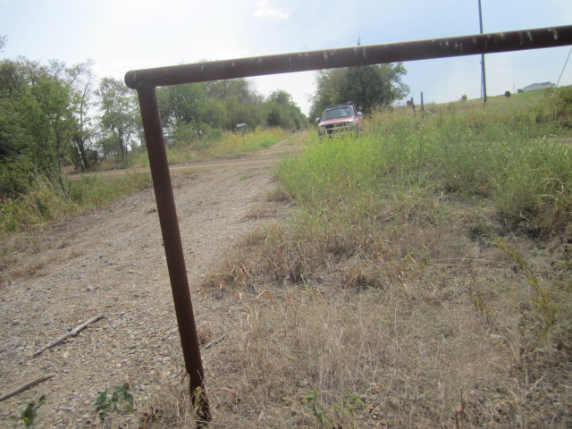 | 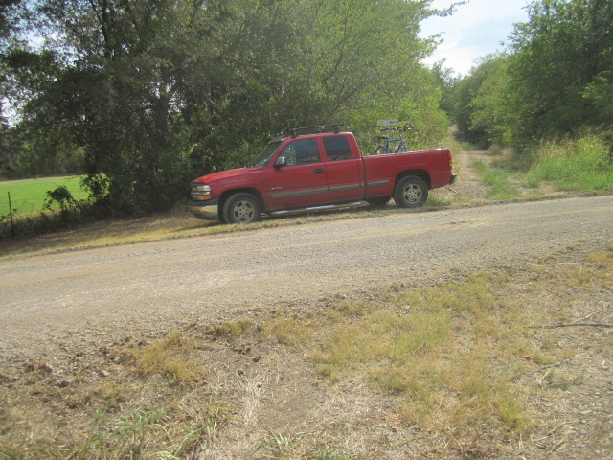
(16) Hunt CR (?) Trail Crossing Between CR 1104 and 1101) Good Parking, Dirt Road | (17) Hunt CR 1101 (North) Trail Crossing  Adequate Parking (CR 1101 is Huge Loop)
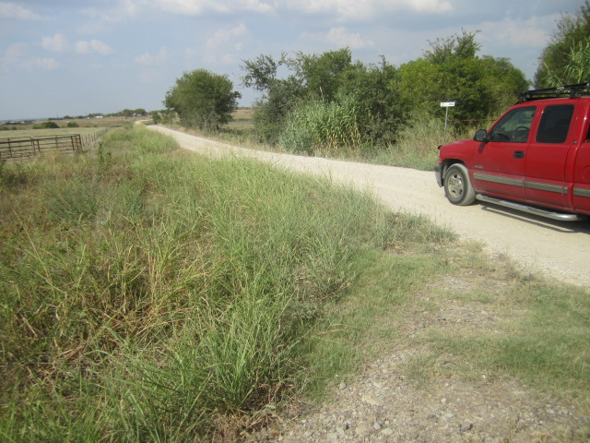 | 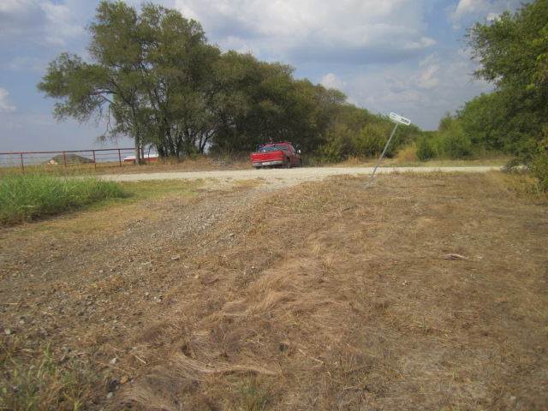
(18) Hunt CR 1098 Trail Crossing, No Adequate Parking (Do Not Block Cattle Pen Access) | (19) Hunt CR 1089 Trail Crossing  Lots of Parking

